**Yolov3: Incremental Improvement**

* **mAP**: min Average Precision
* **IoU**: Area of Overlap / Area of Union (intersection of Union)

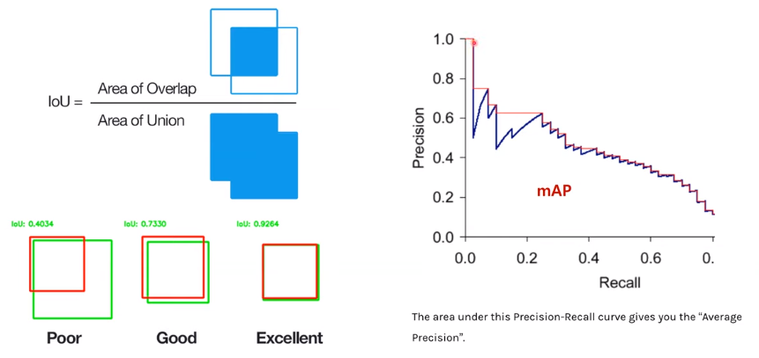

* **Bounding Box Prediction** (기존 yolov2와 다를 바 없다)

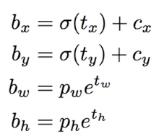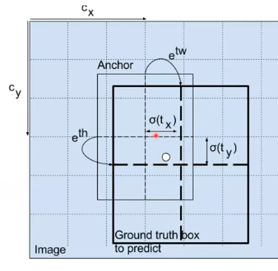

* YOLOv3 only assigns one bounding box prior for each ground truth object (ground truth 하나당 예측한 box 하나) // 기존에는 gt하나에 iou>0.6이상 box matching ㅇㅇ
* YOLOv3 predicts boxes at 3 scales, YOLOv3 predicts 3 boxes at each scale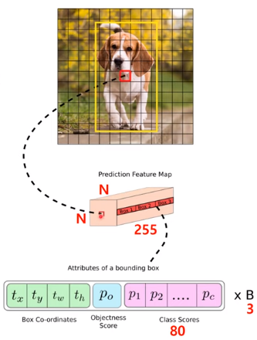-> in total 9 boxes (so tensor is N x N x (3 x (4 + 1 + 80))
* Anchor Boxes >> use k-means clustering to determine bounding box priors
* 